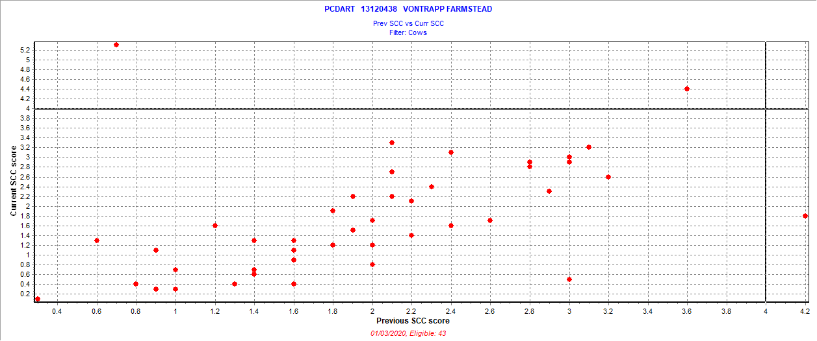

December 62019 test date

New = 2 = 4.7%

Chronic = 0 = 0

Cure = 1 = 2.3%

Uninfected = 40 = 93.0%

Also 1 fresh cow SCC > 3.9